HIRSCH BEDNER ASSOCIATES (HBA) COMPLETES UPSCALE ULTIMA RESIDENCES WITH SUN HUNG PROPERTIES LTD. IN HONG KONG

Ultra Luxury Residences Take Design Cues From Views Of Yachts Sailing Across Victoria Harbour
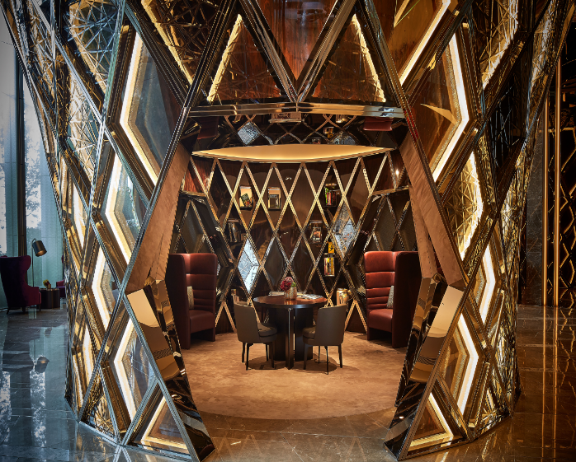
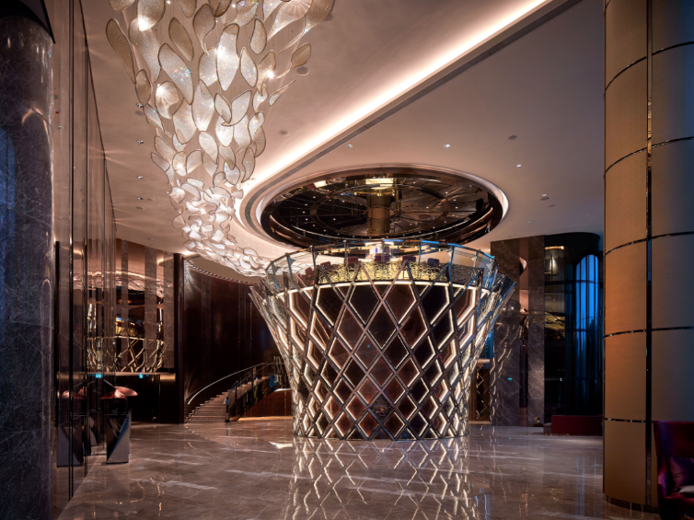

Hong Kong (June 13, 2017) – Hirsch Bedner Associates (HBA), the world’s leading hospitality interior design firm, has completed the design of Ultima, one of the most highly-anticipated luxury residential projects located in the heart of Ho Man Tin, minutes from Victoria Harbour. HBA designers drew design inspiration from the project’s sought-after location, overlooking the luxury yachts sailing across the glittering waters of the harbour.

Behind the elegant exterior, the stately public spaces feature 520 apartments, seven houses, and one clubhouse. To cater to the high-net-worth buyers, facilities include a basketball/ badminton court, gym, spa, outdoor and indoor swimming pool for an overall wellness experience along with a bar, lounge, dining rooms and billiard and mahjong rooms for entertainment. Ultima serves as the flagship residential development of Sun Hung Kai Properties, nestled in the cultivated area of Ho Man Tin.

“The lines and curves of the extravagant yachts sailing across the Harbour dictated the design for these premium residences, which offer residents unparalleled views and luxury in Ho Man Tin,” said HBA Partner Mathew Lui. “HBA further explored this concept through the selection and use of rich materials and intricate details that created a lavish and timeless design that is as sophisticated and fascinating as those who will reside in spaces.”

Through HBA’s design, Ultima couples privacy and innovations of a stately home with the exclusive services expected from a world standard luxury residential development. Units feature unmatched harbor and greenery views, as well as professional facilities management that are on par with five-star hotel accommodations. The interior design applied throughout the development by the HBA team is highly detailed and meticulously planned, resulting in a truly opulent, bespoke project.

To capture the imagination of the most illustrious buyers, HBA developed a showcase feature in the clubhouse – the Crown bar – with a high-detailed façade using repetitive patters, layering of various materials and architectural lighting that towers within the center of the clubhouse. An elegant bar sits atop the structure providing an intimate gathering space for residents.

“This landmark of luxury stands testament to Sun Hung Kai’s continued commitment to offer the highest level of opulent residential development,” said Lui. “The residence itself is set apart all other competitors and anything else offered in the market. Challenged with a compact architectural design with various details and materials, the client’s brief was to ensure the areas appeared spacious and luxurious, all while ensuring world-class services for a first class development.”

###
About Hirsch Bedner Associates (HBA)
World-renowned as the “Number One Hospitality Design Firm” by INTERIOR DESIGN, Hirsch Bedner Associates (HBA), HBA creates the signature looks of today’s luxury brands and unveils the world’s most anticipated hotels, resorts, spas, casinos, restaurants, cruise ships, independent contemporary boutique hotels and world-class residences. Leading the hotel design industry since 1965, HBA remains keenly attuned to the pulse of changing industry trends governed by today’s sophisticated traveler. The company′s international presence, depth of experience, and detailed industry knowledge enables them to identify interior design trends at their source, make definitive predictions about new directions and innovations, and influence design standards at a global level. HBA′s ultimate objective is to add value, raise standards and enhance the brand of a project’s owner and operator.
From continent to continent, each HBA interior is the result of a unique and sensitive response to location, architecture, and client vision. With more than 1,500 designers around the globe in 23 offices in nearly every major city, HBA is a true global company. HBA′s international presence, combined with its extensive knowledge of the interior design industry, has facilitated the ability to rewrite the language of design with each new project. In the past six years, the firm has launched six new design divisions, including Illuminate, Studio HBA, Canvas Art Consultants, HBA Architecture, HBA Graphics and HBA Residential.

In the past year, HBA has been honored by Hospitality Design's Platinum Circle Visionary Award and HD Awards, Boutique Design's Gold Key Awards, MEIDA 2017 Awards, China Starlight Awards, China Golden Pillow Awards, and Best D.E.S.I.G.N. Hotel Awards, to name a few. www.hba.com

