MELBOURNE’S HIRSCH BEDNER ASSOCIATES (HBA) DESIGNS PICKETT’S DELI & ROTISSERIE FOR SCOTT PICKETT AT QUEEN VICTORIA MARKET

Award-Wining Design Team Creates European Style Deli for Casual Dining and Wine Shop, Marking Their Second Restaurant Design with the Celebrated Chef

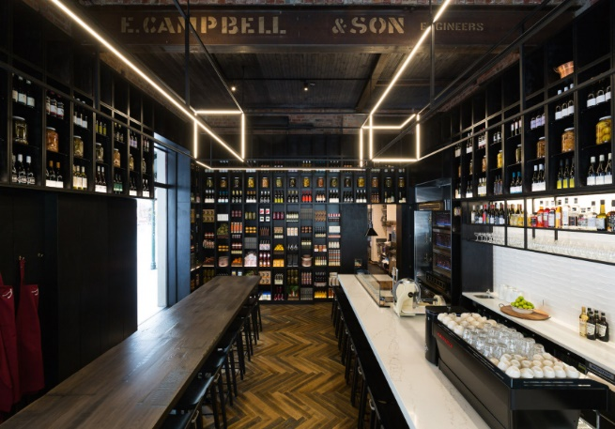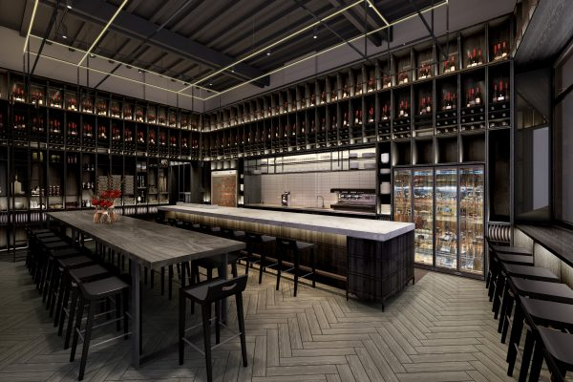
Melbourne (November 30, 2016) – Melbourne’s Hirsch Bedner Associates (HBA), the world’s leading hospitality interior design firm, has yet again created an inspiring dining experience for renowned Chef Scott Pickett and his latest venture – Pickett’s Deli & Rotisserie – a rotisserie and charcuterie station and communal space that invites guests into a familiar, home-like dining experience. Accommodating up to 36 diners, the marble-topped charcuterie counter is lined with stools, providing guests with front row seats to the show-stopping kitchen experience.

HBA designers developed a contemporary deli gourmet rotisserie that juxtaposes a modern-day lifestyle and fine culinary experience against the historic backdrop of the Queen Victoria Market. Creating a captivating, moody atmosphere, HBA designed a dark, masculine scheme accompanied by towering display shelves and 80-year-old reclaimed Tasmanian Oak floors that pay homage to the restaurant’s historic market location. The aged heritage substrate of the building, display shelves and bespoke lighting pendant harmoniously blended the restaurant’s location with the vibrancy of the deli’s modern concept.

“We are so proud to have teamed up with the talented Scott Pickett and his team once again, who allowed us to bring his masterful vision to life through our design,” said Clifford Rip, principal of HBA Melbourne. “We were inspired by the prominent history of Queen Victoria Market to create this dynamic new space. The storied location lent to the narrative that was used to form a modern-day representation of a traditional deli with an overall contemporary theme.”

HBA Melbourne collaborated with Illuminate, HBA’s lighting design firm and HBA Graphics to create a cohesive scheme that told the restaurant’s story through creative imagery, accent lighting and upscale design. A concept that started as a residential provincial kitchen evolved into a heritage project that fully embraced the location and historical style of the deli’s address – Queen Victoria Market, the largest open-air market in the southern hemisphere. The tailored design showcases HBA’s ability to produce bespoke, individual spaces and highlights the firm’s capability in producing a project that seamlessly blends into its surroundings while making a bold statement for the client.

###

About Hirsch Bedner Associates (HBA)
World-renowned as the “Number One Hospitality Design Firm” by INTERIOR DESIGN, Hirsch Bedner Associates (HBA), HBA creates the signature looks of today’s luxury brands and unveils the world’s most anticipated hotels, resorts, spas, casinos, restaurants, cruise ships, independent contemporary boutique hotels and world-class residences. Leading the hotel design industry since 1965, HBA remains keenly attuned to the pulse of changing industry trends governed by today’s sophisticated traveler. The company′s international presence, depth of experience, and detailed industry knowledge enables them to identify interior design trends at their source, make definitive predictions about new directions and innovations, and influence design standards at a global level. HBA′s ultimate objective is to add value, raise standards and enhance the brand of a project’s owner and operator.

From continent to continent, each HBA interior is the result of a unique and sensitive response to location, architecture, and client vision. With more than 1,500 designers around the globe in 23 offices in nearly every major city, HBA is a true global company. HBA′s international presence, combined with its extensive knowledge of the interior design industry, has facilitated the ability to rewrite the language of design with each new project. In the past six years, the firm has launched six new design divisions, including Illuminate, Studio HBA, Canvas Art Consultants, HBA Architecture, HBA Graphics and HBA Residential.

In the past year, HBA has been honored by Hospitality Design's Platinum Circle Visionary Award and HD Awards, Boutique Design's Gold Key Awards, MEIDA 2017 Awards, China Starlight Awards, China Golden Pillow Awards, and Best D.E.S.I.G.N. Hotel Awards, to name a few. www.hba.com

