HBA RESIDENTIAL BRINGS LUXURY INTERIOR DESIGN HOME FOR ULTRA-HIGH-NET
WORTH INDIVIDUALS
Highly-specialized Team Provides Full Suite of Residential Services for the World’s Most Luxurious Residences

SINAGPORE, July 20, 2016 – Hirsch Bedner Associates (HBA), the world’s leading hospitality interior design firm, brings its signature styling to private residences around the world with HBA Residential, a boutique residential interior design firm catering to private clients and developers of elite private villas, penthouses, luxury buildings and homes. HBA Residential offers a unique combination of holistic design, tremendous quality control and sublime personal service to its distinguished clientele.

Working with just a handful of select clients for an intimate, tailored experience, Principal Chris Godfrey of HBA Residential provides his discerning clientele with an unparalleled level of intimate service – privacy being paramount – engaging with each person to develop a collaborative relationship that creates luxury through design. Godfrey and his global team demonstrate a keen understanding of their client’s lifestyles to create ultra-high quality environments that support, promote and enhance their quality of life.

“Our discerning international clientele are wealthy in their experiences and their homes serve as a reflection of their life’s journey, a true sanctuary with beautiful and layered story to tell,” says Godfrey. “The first step in our process is to build an emotional connection with each person to fully understand their desires for their lives and homes. We work meticulously to translate each story into the world’s most exceptional residences, reflecting each family – the process is just as extraordinary as the result.”

When collaborating with developers to create exceptional residences for homebuyers, the HBA Residential team is keenly attuned to key drivers and market forces in order to add value to each project. They carefully focus on the commercial and aspirational lifestyle aspects of residential design for a commercially delivered, high-design project.

HBA Residential is a full-service boutique for world-wide design offering a broad range of architectural, interior design, and furniture procurement services – the team looks after clients throughout various stages of the home creation process, from selecting a plot of land to designing a custom piece of furniture.

Offering exquisite home design for the world’s most distinguished individuals, HBA Residential is comprised of highly-skilled, creative architects and interior designers skilled in designing bespoke residences that exude personality, heart and soul. The firm’s scalable design approach can address every aspect of the project, equally and holistically, from the building envelope to the door handle.
###

About HBA Residential
An independent division within the Hirsch Bedner Associates (HBA) family, HBA Residential creates distinctive, sophisticated and sublime environments for private villas, penthouses, luxury buildings, and houses. HBA Residential services include architecture, interior design and FF&E (furniture, fixtures, and equipment). From concept to completion, drawing to door handle, the HBA Residential team of professionals creates and executes designs for bespoke residences around the world. http://hbaresidential.com/

About HBA
World-renowned as the “Number 1 Hospitality Design Firm” (Interior Design) HBA/Hirsch Bedner Associates, unveils the world’s most anticipated hotels, resorts, and spas. Leading the hospitality interior design industry since 1965, HBA remains keenly attuned to the pulse of changing industry trends governed by today's sophisticated traveler. The company’s international presence, depth of experience, and detailed industry knowledge enables them to identify interior design trends at their source, make definitive predictions about new directions and innovations, and influence design standards at a global level. HBA’s ultimate objective is to add value, raise standards and enhance the brand of a project's owner and operator.

HBA creates the signature look of traditional luxury brands, independent contemporary boutiques, urban resort spas, world-class residences, restaurants, casinos, and cruise ships. From continent to continent, each HBA interior is the result of a unique and sensitive response to location, architecture, and client vision. With over 1,500 designers around the globe in 22 offices, HBA is a true global company. HBA’s international presence, combined with its extensive knowledge of the interior design industry, has facilitated the ability to rewrite the language of design with each new project.

For HBA in Atlanta, Los Angeles, San Francisco, Miami, London, Dubai, Delhi, Mumbai, Melbourne, Tokyo, Singapore, Bali, Jakarta, Bangkok, Hong Kong, Shanghai, Guangzhou, Beijing, Clark, Manilla, Jeddah, Istanbul, please visit www.hba.com

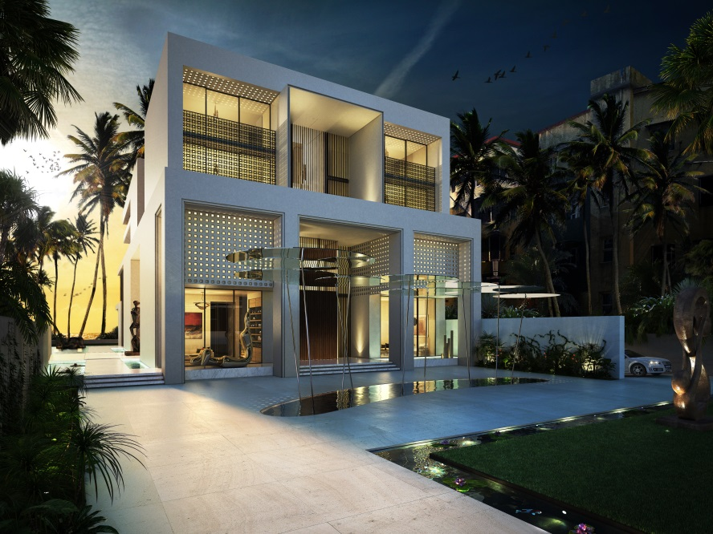
HBA Residential’ s recent project in Mumbai
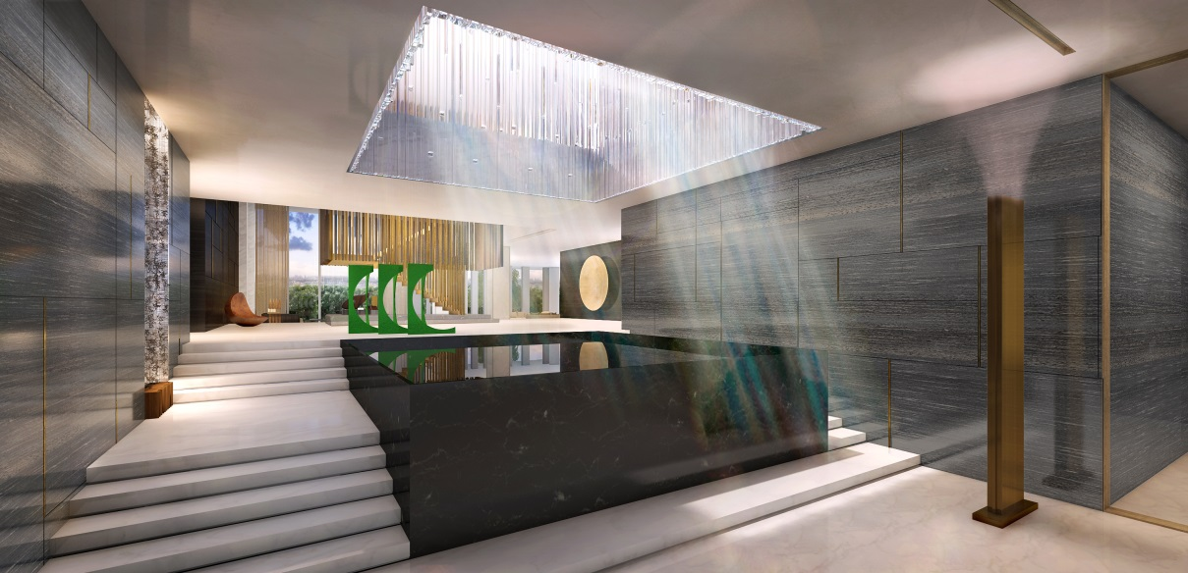
HBA Residential’ s recent project in Xi’an

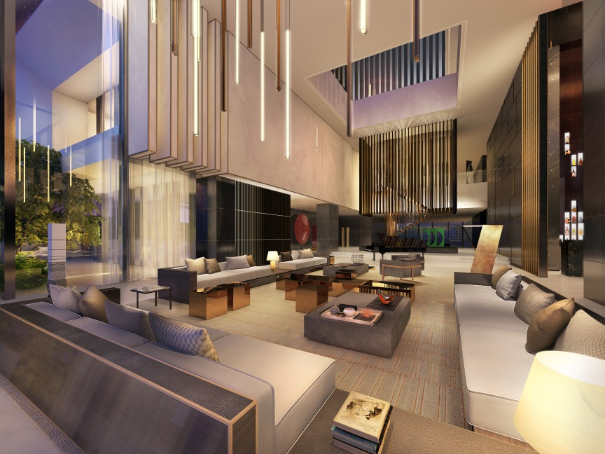
HBA Residential’ s recent project in Xi’an

