HBA/HIRSCH BEDNER ASSOCIATES UNVEILS ITS DESIGNS FOR RAFFLES JAKARTA AT CIPUTRA WORLD JAKARTA 1
First Raffles in Indonesia; World’s Top Interior Design Firm Creates an “Ode to Artist Hendra Gunawan”

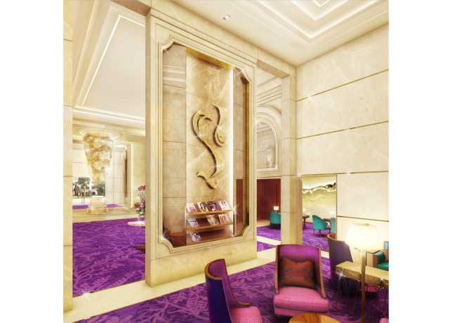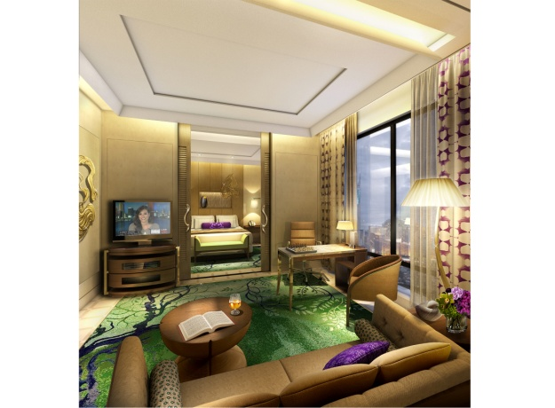

Jakarta, Indonesia (March 16, 2016) – HBA, the global leader in hospitality interior design has completed the new 173-room Raffles – the first in Indonesia – creating an “Ode to Hendra Gunawan.” Combining the colorful spirit of the beloved Indonesian artist, Gunawan, with the richness and nostalgic elegance of classic design, Raffles Jakarta explores all avenues of creative reinterpretation.
“Believed to be one of Indonesia’s greatest painters, Hendra’s personal style and innovative approach to his art became an iconic thread throughout the hotel’s interior design,” says David T’Kint, Lead Designer and Partner at HBA Dubai. “Explosions of immense color amidst a backdrop of golden tones transform the everyday hotel experience into an exploration of art.”
Upon entry, the lobby and reception greets guests with an amazing sense of grandeur and elegance. Warm golden toned marble is contrasted with rich veins of onyx from floor to ceiling, creating a canvas within the space, and is a reoccurring detail throughout the hotel. Guests are invited to sit upon the elongated, 4 meter chaise lounge to admire the colorful collection of hand-blown glass that transforms the ceiling into a sculptured piece of art.
The vividness of color and expressive use of line in Hendra’s paintings are captured in soft furnishings and unique lighting fixtures in the lobby. Large installations of artwork on the walls and ceilings are creative replicas of Hendra’s paintings hand selected by Pak Ciputra (owner) himself from his private collection.
Adjacent to the lobby is the Writer’s Bar, where the playful and bespoke design tells the story of Hendra’s early childhood experiences and his love of color and nature. The ceiling is sculpted with showering crystals while vibrant fish swim through the custom made carpet below.
The guestrooms represent the artist’s retreat, whereby the subtle collaboration of art and luxury meet, fusing an air of superior relaxation. The bedroom is kept separate from the lounge making each room feel like a suite. Warm beige stone and wood are combined within the millwork and flooring creating a complimenting backdrop to the colorful tones of the furniture and accessories.
Touches of Raffles’ romantic and classical architectural details are felt throughout the hotel and are especially evident in the lobby, ballroom, meeting room, and guestrooms. These details are reintroduced with a touch of modern refinement and elegance, combining the lush nature of Indonesia with the timeless design of Raffles.
Pak Ciputra’s vision to give a tribute to Hendra Gunawan is evident throughout Raffles Jakarta; creating a destination where the passion of those who are inspired to create come together.
About Hirsch Bedner Associates (HBA)
World-renowned as the “Number One Hospitality Design Firm” by INTERIOR DESIGN, Hirsch Bedner Associates (HBA), HBA creates the signature looks of today’s luxury brands and unveils the world’s most anticipated hotels, resorts, spas, casinos, restaurants, cruise ships, independent contemporary boutique hotels and world-class residences. Leading the hotel design industry since 1965, HBA remains keenly attuned to the pulse of changing industry trends governed by today’s sophisticated traveler. The company′s international presence, depth of experience, and detailed industry knowledge enables them to identify interior design trends at their source, make definitive predictions about new directions and innovations, and influence design standards at a global level. HBA′s ultimate objective is to add value, raise standards and enhance the brand of a project’s owner and operator.
From continent to continent, each HBA interior is the result of a unique and sensitive response to location, architecture, and client vision. With more than 1,500 designers around the globe in 23 offices in nearly every major city, HBA is a true global company. HBA′s international presence, combined with its extensive knowledge of the interior design industry, has facilitated the ability to rewrite the language of design with each new project. In the past six years, the firm has launched six new design divisions, including Illuminate, Studio HBA, Canvas Art Consultants, HBA Architecture, HBA Graphics and HBA Residential.
In the past year, HBA has been honored by Hospitality Design's Platinum Circle Visionary Award and HD Awards, Boutique Design's Gold Key Awards, MEIDA 2017 Awards, China Starlight Awards, China Golden Pillow Awards, and Best D.E.S.I.G.N. Hotel Awards, to name a few. www.hba.com.

