STUDIO HBA DESIGNS COURTYARD MARRIOTT AND HAMPTON INN & SUITES IN SANTA MONICA, CALIF. DRAWING INSPIRATION FROM SANTA MONICA COASTLINE
Studio HBA Reimagines Brand Standards for Two New Hotels by Infusing Locality Into Boutique-style Design; Dual-designed Properties are Inspired by a Road Trip Along Historic Route 66, Ending at the Santa Monica Pier

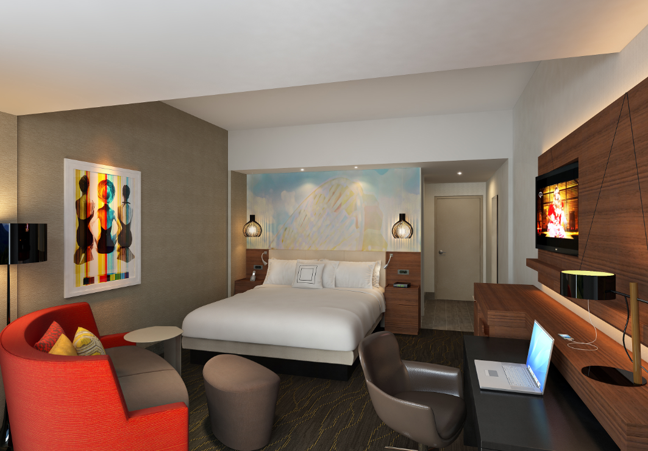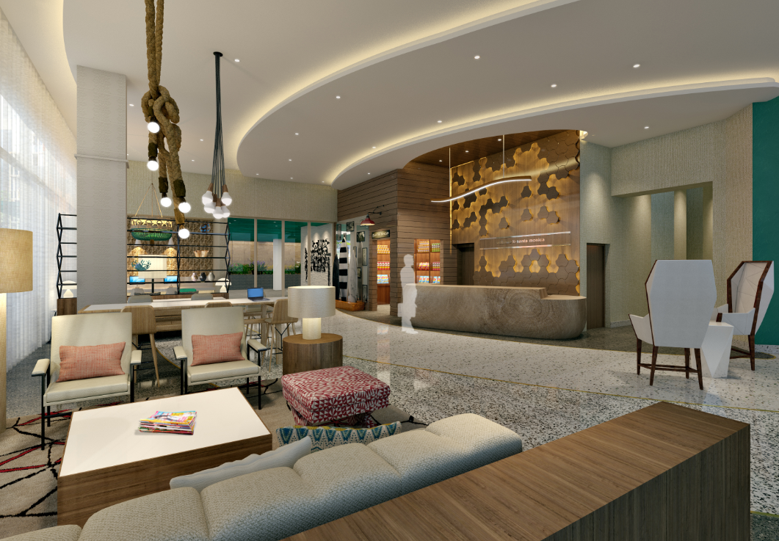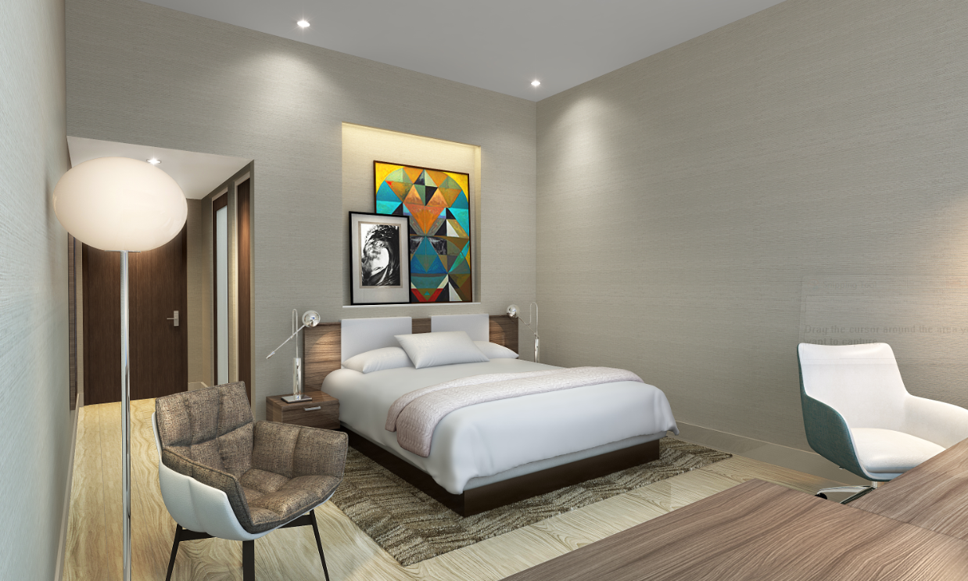

LOS ANGELES – June X, 2016 – Studio HBA, a division of the world’s leading hospitality interior design firm, Hirsch Bedner Associates (HBA), specializing in budget-driven, responsive interior design, announces the pending completion of two hotels in its own backyard of Santa Monica, California. Courtyard Marriott and Hampton Inn & Suites were designed in tandem to complement one another, each reflecting a different element of the Santa Monica Coastline, Courtyard Marriott representing the beach town’s bluffs while Hampton Inn reflects the fluidity of the iconic California waves. Exteriors for both properties were designed by Gwynne Pugh Urban Studio and scheduled to open September 2016 to meet the growing travel demand placed upon the city with the May opening of seven new Expo Line stops, connecting Downtown Santa Monica to Downtown Los Angeles.

“The designs of the Courtyard Marriott and Hampton Inn & Suites are inspired by the excitement of a road trip to the end of Route 66 and the experiences and elements of nature that are encountered along the way,” said David Dunphy, principal at Studio HBA. “In designing both hotels in conjunction with one another, we wanted guests to feel a sense of arrival at each – that their journey to the beach has ended and their time at the beach has begun. Both designs are a complete departure from the hotels’ typical brand standards as they deeply rooted in California’s west coast culture, emitting a young, vibrant, yet relaxed energy.”

Courtyard Marriott Santa Monica
Located on the corner of 5th and Colorado with 136 rooms, the Courtyard Marriott displays an earthy design, with an overarching theme of the earth’s tectonic plates prevalent throughout. As guests enter the hotel, edge-lit ceiling forms – created by Illuminate lighting consultancy – representing the earth’s plates radiate from the front desk, increasing in height where they culminate at a “cloud-like” light fixture designed by Illuminate and a full-height media wall providing a dramatic counterpoint. Oversized digital “Polaroids” are on display allowing for Route 66 travel imagery to be shown for a dynamic and localized art scene in the lobby area. Illuminate dramatically-lit a three-dimensional topographic map of Santa Monica to serve as a focal piece behind the front desk with suspended wood planes floating above. Sustainable earth-toned stain was applied to the concrete slabs on the floor, rather than traditional imported floor tile, adding warmth and supporting Santa Monica’s environmentally-friendly mindset. Casual seating groups throughout the lobby standout with colorful area rugs and provide guests with various areas to either work or meet with friends, adding transitional spaces for the hotel to use in various capacities.

Working hand-in-hand with Studio HBA, Santa Monica-based Illuminate, a lighting consultancy under HBA, created a new standard in lighting design for the Courtyard by Marriott brand. The vibrant lighting scheme and concealed LED fixtures reveal the building’s rugged architectural exterior, an earthy design inspired by Santa Monica’s renowned beaches. Interiors are accentuated by high-efficiency LED lighting and dynamic lighting controls, all working in concert with the interior design features to create a dynamic and exciting environment that celebrates the hotel’s beach town energy.

Elevator lobby walls are adorned with local art, silk screened onto glass featuring the iconic Santa Monica 66 “End of the Trail” sign and the Santa Monica Pier. A pool deck and terrace with glowing furniture and fire pits on the second floor overlooks the newly opened metro station and Pacific Ocean beyond.

The contemporary guestrooms are tailored to their locale as a full headboard wall complete features a graphic image of the Santa Monica Pier in sunset-inspired hues setting the for the famed California beach vibe. All case goods are customized with wood veneers in warm rich walnut tones and routed reveals recalling the tectonic plates from the lobby below. Abstract art in the rooms includes a graphic depiction of the 1950’s era bathing beauties and a full wall in the bathroom showing bubbles ascending in water printed on wall covering to give dramatic visual impact in the otherwise clean, crisp white bathroom palette. Top floor suites in the hotel are spacious and contemporary with large balcony, generous outdoor seating, fireplaces and built-in bars overlooking the striking views of the Santa Monica Pier and beyond.

Hampton Inn & Suites Santa Monica
Located directly across the street from the Courtyard Marriott and designed to reflect the fluidity of water, representing the arrival at the Pacific Ocean, the Hampton In and Suites will feature 146 rooms. The lobby greets guests with sweeping curved, edge-lit ceiling planes by Illuminate stepping up from a sculptural “driftwood” front desk that flows through the entire ground floor of the hotel, linking all the areas together in a fluid motion. Terrazzo flooring with recycled content is being used both for its sustainability and its ability to accommodate the sweeping curvilinear design of the flooring to mirror the ceiling above. The Terrazzo material allows subtle color gradations to reflect the layering effects of water as it collides with the beach. A series of carved stone surfboards and local historic surf photos just inside the entry pay homage to Santa Monica’s affinity for all things aquatic. Casual seating groups were designed to appear as an assemblage collected over time and hammock chairs are will suspend from the ceiling next to rope light fixtures, alongside a woven wall of ship rope to add visual texture to the lobby.

Illuminate collaborated with Studio HBA once again to develop a lighting installation that reflects the fluid movement and energy of this iconic Los Angeles destination. The linear LED lighting installation flows into the hotel’s main lobby, taking the form of waving ceiling coves inspired by the southern California shoreline. High-efficiency LED and green lighting technologies were used throughout the property to enhance the design’s overall narrative of a modern, beach-inspired interior, while maintaining the highest level of energy conservation.

Similar to the Courtyard Marriott, the elevator lobby walls are filled with graphic art, silk screened onto glass featuring colorful geometric patterns that culminate in an oversized image of a swimmer donning a bathing cap with three dimensional water drop patterns surrounding lights in the ceiling above. A dramatic deck on the second floor features bespoke furniture elements, a large 20-foot fire pit, communal sofa and pool-length neon art depicting a series of swimmers moving across the space. Illuminate provided exterior lighting design to illuminate the area for day and nighttime use, to maximize the use of space at the hotel.

The contemporary guestrooms feature an accent wall of wood wall coverings at the desk area that add warmth and texture to the room along with contemporary art pieces placed on a shelf above the upholstered headboard with dramatic lighting. All case goods are custom with wood veneers in warm medium walnut tones and feature integral lighting elements that reflect the fluidity of design throughout. Wood and glass sliding doors into the bath area allow natural light and greater maneuvering space, giving a more open and spacious feeling. Bathrooms exhibit an overall light and airy tone with light floors and walls and a clean, crisp white bathroom palette accented by a subtle mosaic tile wall.

Top floor suites in the hotel are spacious and contemporary featuring kitchenettes, expanded living areas, and large balconies with generous outdoor seating and dramatic views overlooking Santa Monica.

###

About Studio HBA
Studio HBA is a division of Hirsch Bedner Associates (HBA), the world’s leading hospitality design firm, and carries HBA’s DNA in its daily practice. Studio HBA specializes in servicing an international client base with smaller fee budgets and caters to local hoteliers and developers to deliver cutting-edge design solutions. The young, energetic, research-based design practice collaborates closely with clients and stakeholders to complete projects that meet exacting budget demands and brand requirements within limited timeframes. Studio HBA’s project resume includes hotels, resorts, private residences, show flats, restaurants, spas, clubs and corporate offices. The practice crafts a tailored approach to each project, enabling the firm to be a single-source hospitality provider with services including: interior design, architecture, art consultation, lighting design, graphic design, FF&E procurement, affording clients the opportunity to choose integrated comprehensive services or from an a la cart menu of disciplines. Studio HBA’s notable completed projects include Courtyard San Francisco Union Square and Hilton Woodland Hills in Los Angeles. In 2016, Studio HBA’s Los Angeles office will unveil three local projects – Plaza la Reina in Los Angeles, Hampton Inn Santa Monica and Courtyard Marriott Santa Monica. http://www.studiohba.com/

About Illuminate
Illuminate is a lighting design consultancy and division of Hirsch Bedner Associates (HBA) working with architects, interior designers, landscape architects, and end clients across Asia, Middle East, Europe and America on a wide range of commercial and residential projects.
http://www.illuminateld.com/

